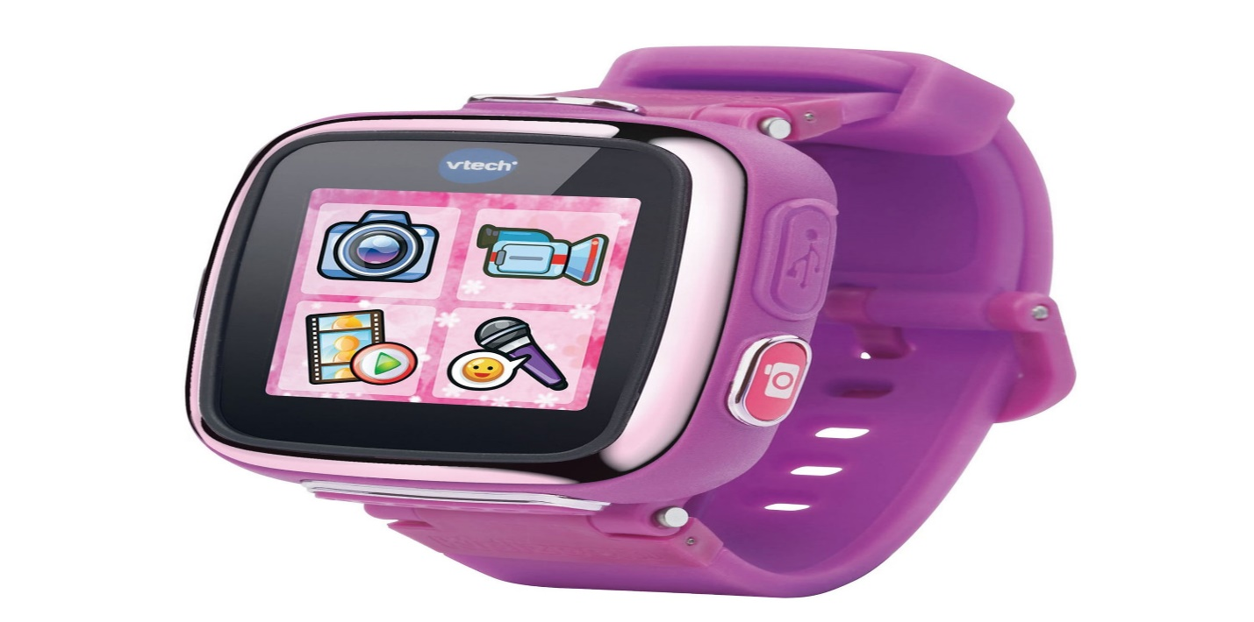Vetch Kidizoom

Description: **Vetch Kidizoom** is a popular brand offering **fun, durable, and educational smartwatches** designed specifically for children. These watches combine interactive features with a child-friendly design, providing a great introduction to technology while ensuring safety and simplicity for younger users. Vetch Kidizoom watches are designed with fun and practicality in mind, helping kids learn, play, and explore while keeping track of time.

The **Kidizoom Smartwatch DX2** is one of the most well-known models, offering a range of features that are both entertaining and educational. It includes **interactive games**, a **camera** for taking photos and videos, **time-teaching tools**, and a **pedometer** to encourage physical activity. Kids can customize the watch with fun **watch faces** and even use it as a **gaming device**, making it a perfect choice for children who are ready for their first smartwatch.